Potential Flow Around Greenhouse

Group 7

Pavan Shukla

Benjamin Helm

Yaashi Khatri

1. Force Coefficients

* Cx = 9.73004 x 10-4
* Cy = -8.01344 x 10-6
* Cz = 7.75036

1. Pressure Coefficient Plot

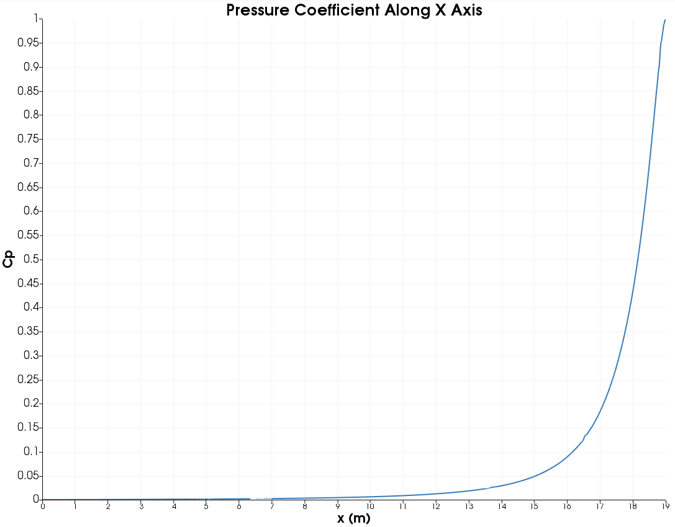

1. Greenhouse Flow Visualization

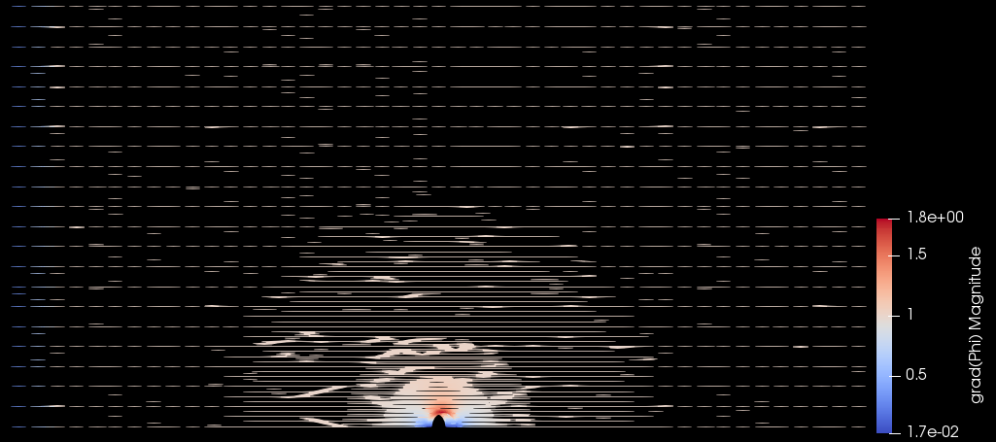

1. Mesh Cell Counts

|  |  |
| --- | --- |
| Mesh | Cell Count |
| Mesh A | 40,656 |
| Mesh B | 81,312 |
| Mesh C | 162,624 |

1. potentialFoam Execution Time

|  |  |  |  |
| --- | --- | --- | --- |
|  | potentialFoam Execution Time (seconds) | | |
| Number of Cores | Mesh A | Mesh B | Mesh C |
| 1 | 115.41 | X | X |
| 4 | 28.62 | X | X |
| 8 | 15.17 | 100.53 | X |
| 16 | 8.44 | 53.65 | 110.7 |
| 32 | 5.24 | 32.02 | 62.71 |
| 64 | X | 24.94 | 40.29 |
| 128 | X | 31.24 | 39.02 |
| 256 | X | X | 45.08 |